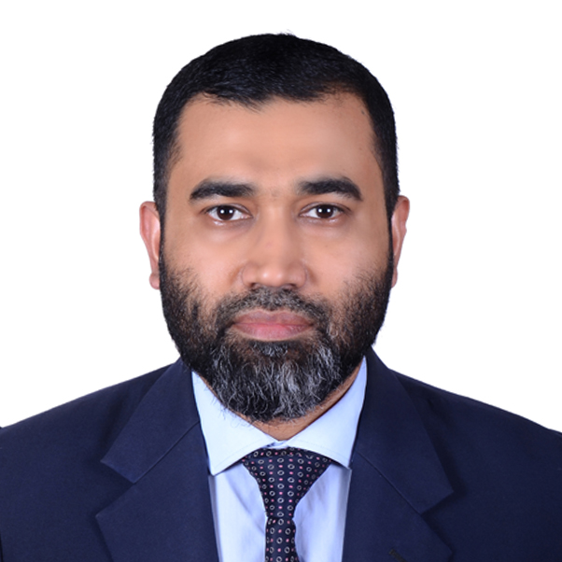

**Abu Zafar Md Sadequl Islam**

**Phone**: +8801712992124

**Email**: khaledzafar84@gmail.com

**Github**: https://github.com/khaledzafar

**Linkedin**:https://www.linkedin.com/in/abu-zafar-md-sadequl-islam-133130189/

**Address**: 36, Mojumdari, Sylhet

**Career Objective**

The aim of the professional is to attach with Software Quality Assurance (SQA) developing profession where anyone can compete with any challengeable needs. I can be able to survive in this challengeable sector as a professional. I will try my best to do my job honestly and dynamically. Also try to prove my skills and abilities in a challenging career where I have to learn and take greater responsibilities and keep myself honest.

**Skills**

* Manual Testing : Requirement Analysis, Test Planning, Designing, Writing and Reviewing Test Cases, Test Execution and Evaluation, Creating Test Report, Root cause analysis &Bug Reporting using test management tools
* Performance Testing Tool: **JMeter**
* API Testing Tool: **Postman**
* Agile Methodology and Project Management Tool: **Jira**
* Concepts: **SDLC, STLC, OOP**
* Database: **MySQL**
* Source and Version Control: **GitHub**

**Educational Qualifications**

|  |  |  |  |  |  |  |
| --- | --- | --- | --- | --- | --- | --- |
| **SL** | **Certification Name** | **Discipline/Major** | **School/College/**  **University/Institute Name** | **Current Status** | **Passing**  **Time** |  |
| 1. | MBA | HRD | Leading University | Passed | 2011 |  |
| 2. | BBA | Marketing | Leading University | Passed | 2008 |  |
| 3. | HSC | Business Studies | Madan Mohon College | Passed | 2003 |  |

**Sample Works-Manual Testing**

* **Test Case Writing**

Link**: github link**

* **Load Testing Using Jmeter**

Link**:github link**

* **API Testing Using Postman**
* Link**: github link**

**Sample Works-Automation Testing**

* **Web Automation Testing**
* **Project Name**

Link: **github link**

* **Mobile Automation Testing**
* **Project Name**

Link: **github link**

**Training**

* **SQA and Cyber Security**( July 23rd,2022 to September 23rd,2022 )
  + **IT Training BD**, a United States based training organization.
  + **Fb Link:** <https://www.facebook.com/It-Training-Bd-211709726924087>

**References**

|  |  |
| --- | --- |
| **Sabiul Islam Rashed**  Sr. SQA and Automation Engineer  Portonics Ltd., MY Telenor Mobile  Cell: +8801630211216  Email: 234sabiul@gmail.com |  |

Date : 29.07.2022

Dear Sir/Madam,

Its my pleasure to work with your organization as a Software Quality Assurance (SQA) engineer and applied for this open post through Linkedin on 20.07.2022.

I am expecting in CV my academic records and Proffessional Degree related to SQA match with your requirements which is attached to this mail.

I will be delighted to get response from your esteemed organization and provide significant impact to this given post.

**(Abu Zafar Md Sadequl Islam)**

**Phone**: +8801712992124

**Email**: khaledzafar@gmail.com